Experiment -3
Name: Harshavarthini A Roll No: 240701181

Problem Statement :
Difference between CLI(Command line interface) and GUI(Graphical user interface) and VUI(voice user interface)

Searching for a File
CLI (Command Line Interface):
● A Text-based Interface (Command line interface)
enables users
to communicate with a computer using the command line, as
opposed to using a graphical interface.
● Compact and Powerful – CLI is usually faster and more powerful
than a GUI, particularly for expert users who know the correct
commands.
● Automation & Scripting – The command-line interface is there to
allow users to automate tasks with scripts, making the repetitive
tasks easier.
● Lightweight and Resource Friendly – Compared to GUI
application, CLI uses very little system resources which is why
they are most suited for use on remote servers
example: Windows command prompt

Implementation:
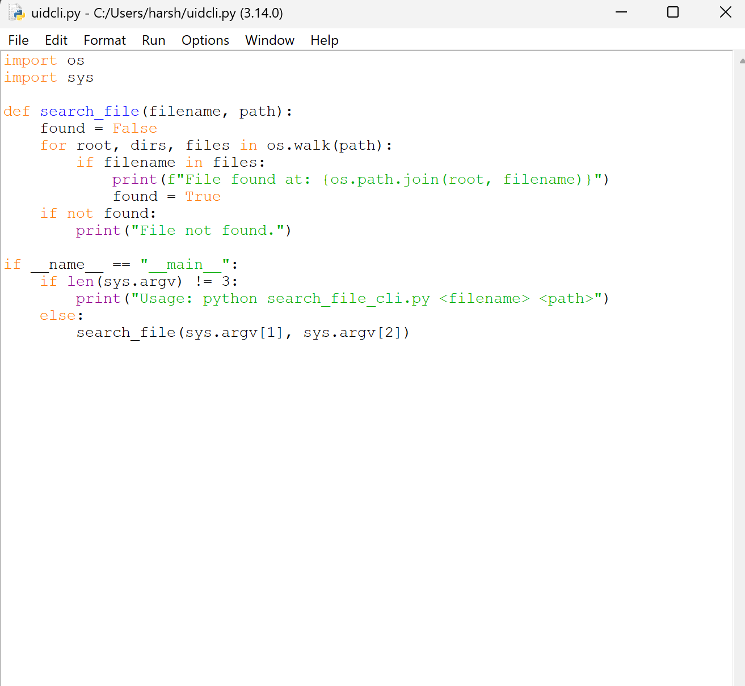

How it works:
- Takes filename and directory path as input
- Uses os.walk() to search all folders
- Prints file location if found

Output:



GUI (Graphical User Interface):
- A GUI uses visual elements including icons, buttons, and windows which makes it more user-friendly for users to work with the system.
● More Resource Intensive – GUI applications use more system resources (CPU, RAM, and GPU) in contrast to a Command Line Interface (CLI) that can degrade performance in low-end
devices.
● Limited Automation: GUI does not have automation and scripting abilities like the CLI and is thus more tedious for repetitive jobs.
example: Windows, Android, iOS

Implementation: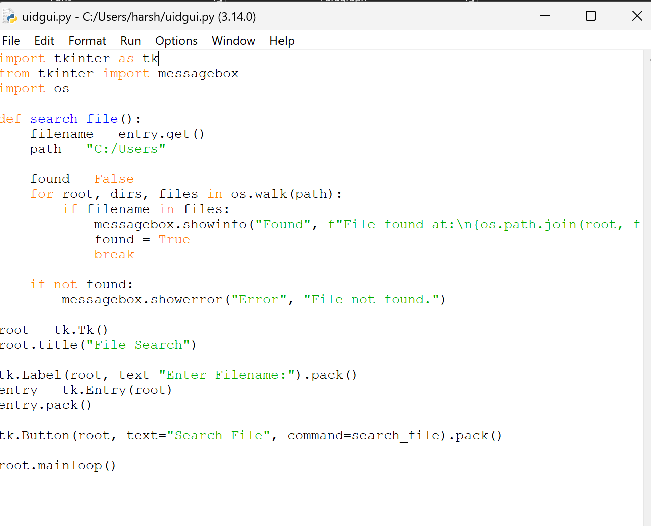

How it works:
- User enters filename in input field
- Clicks “Search File” button
- System searches and shows result in popup

Output:

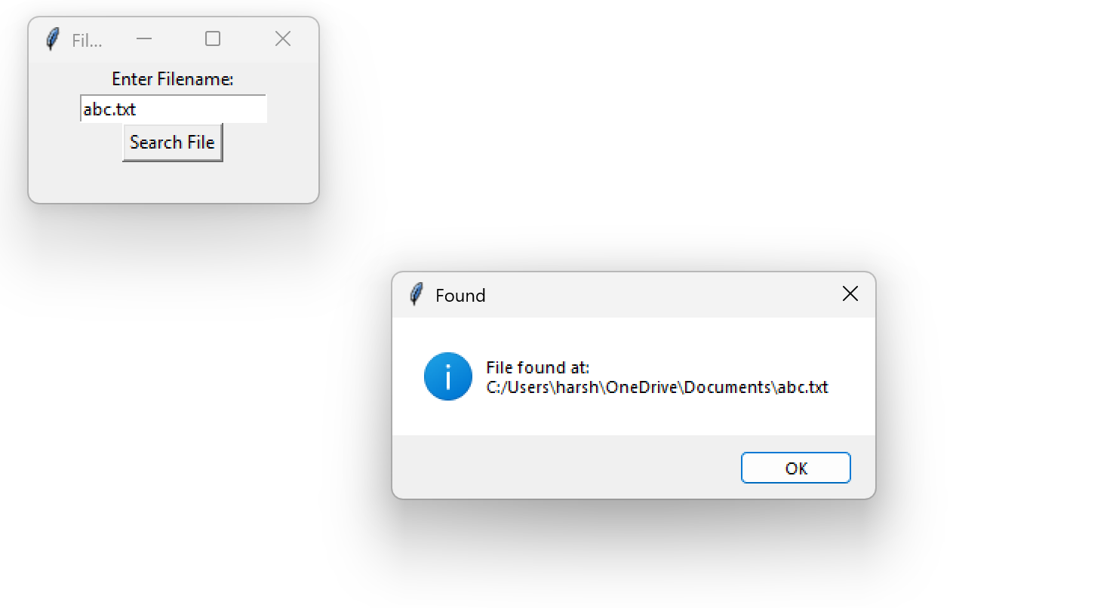

VUI (Voice User Interface):
• No Hands – VUI allows me to talk to a system and in some cases, this is much more convenient than having to type.
• Natural Communication– VUI allows for more natural and fluid communication, as it can process users’ speech and verbal commands, eliminating typing or clicking.
• Accuracy Challenges – Speech recognition can occasionally have difficulty with accents, background noise, and complex commands, sometimes resulting in misinterpretation.
example: Amazon, Alexa, Google Assistant

Implementation:
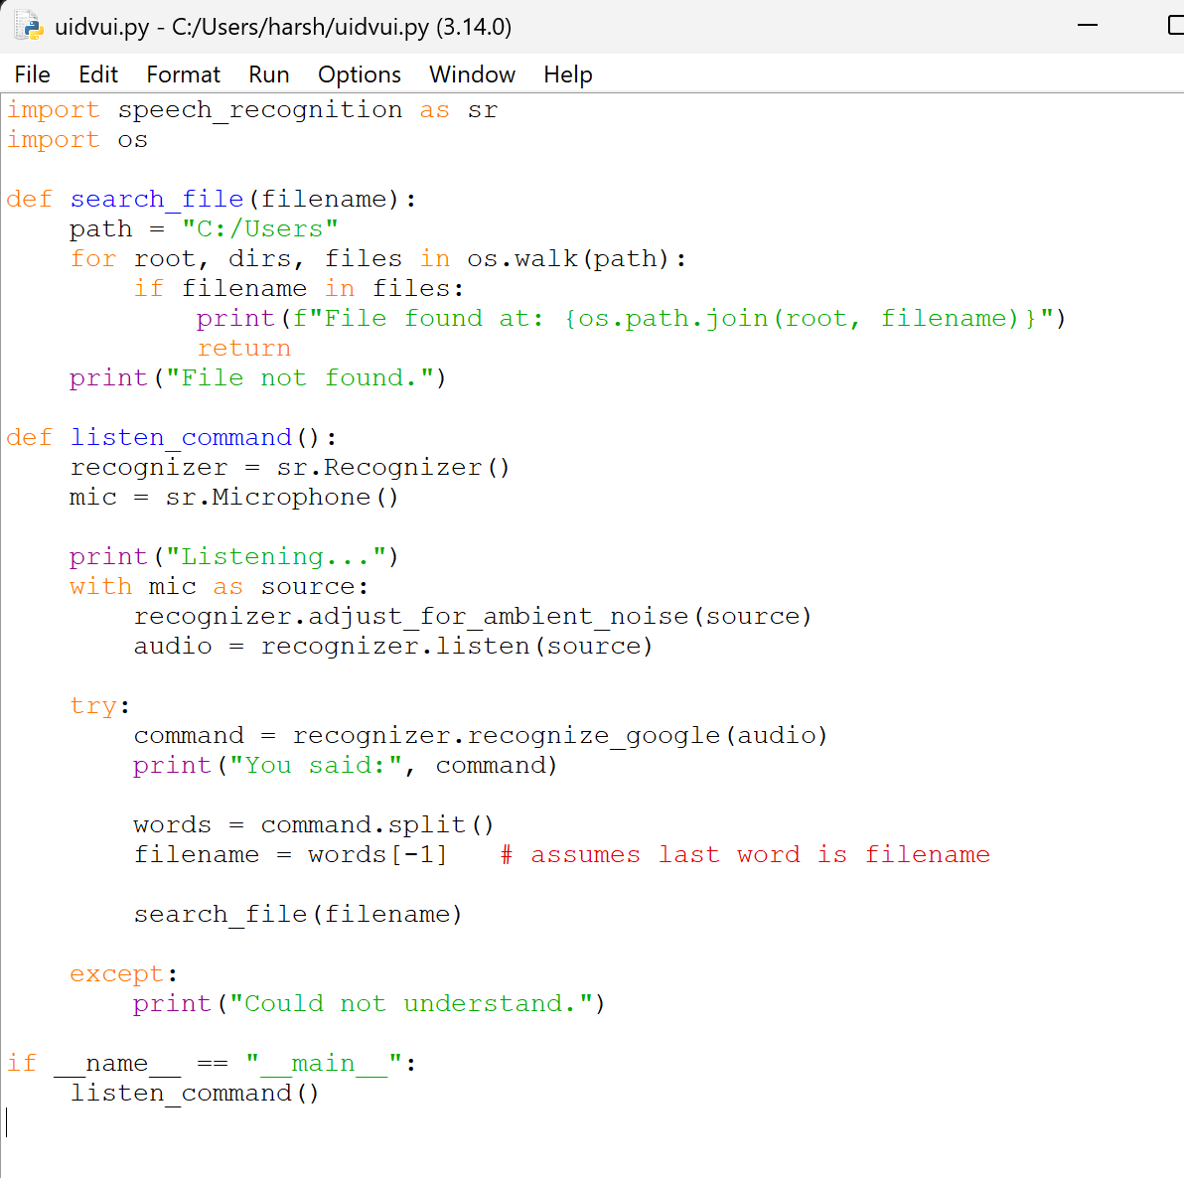

How it works:
- Listens to voice input
- Converts speech to text
- Extracts filename
- Searches file in system

Output:

